Unit 5 Day 3

Today, we are going to learn how animals are alike and different.

How are animals alike and different?

Can you think of how animals are alike? How they are different?

We are going to read a story call “For Pete’s Sake”, by Ellen Stoll Walsh.

Before reading, look at the first page. What do you think might happen in this story?

Once you have thought about what might happen in the story, look through the story and look at the pictures.

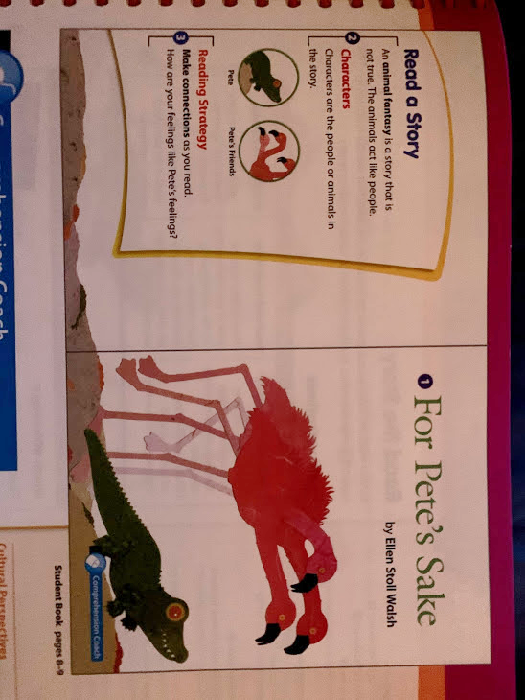 Do the pictures help you think about what might happen?

As you read the story, think how the animals are alike and different.

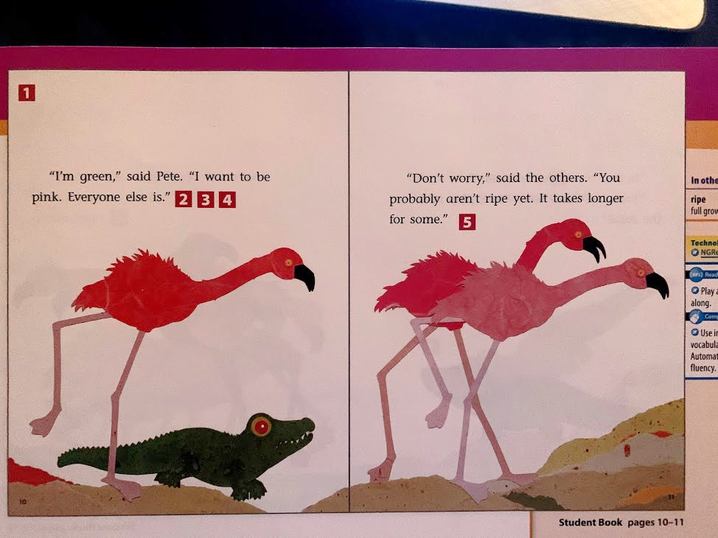

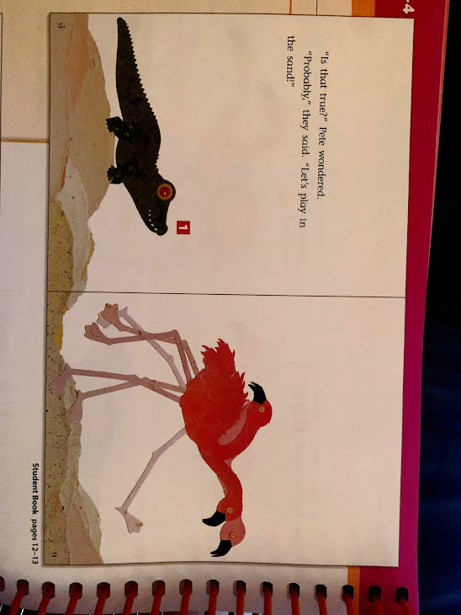

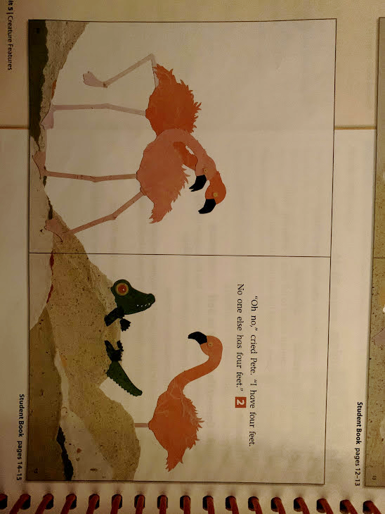

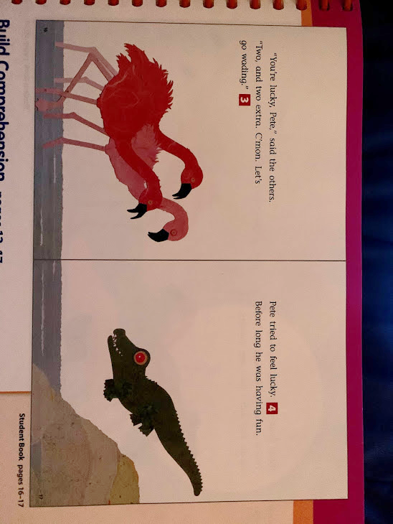

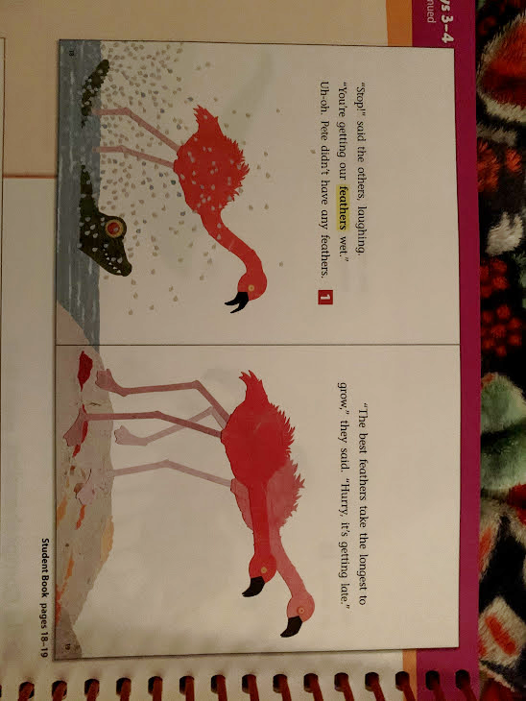

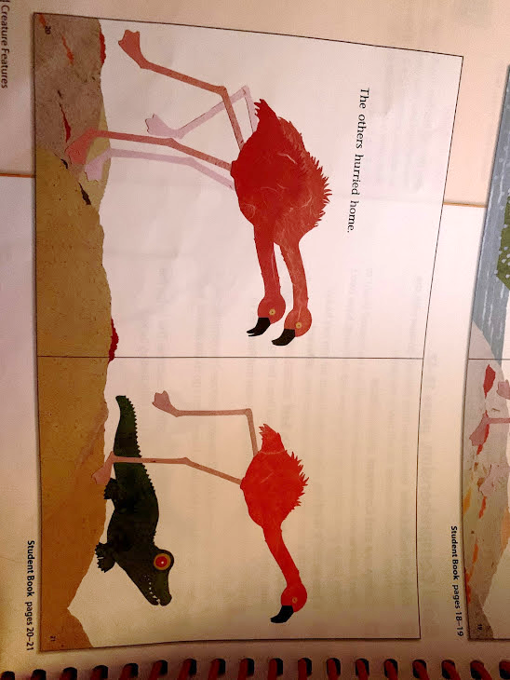

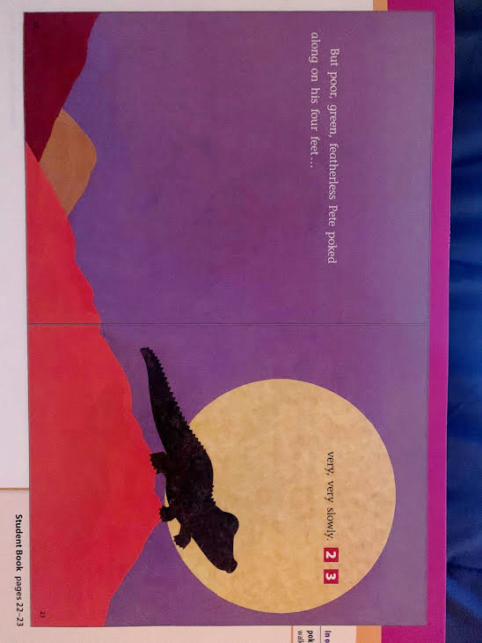

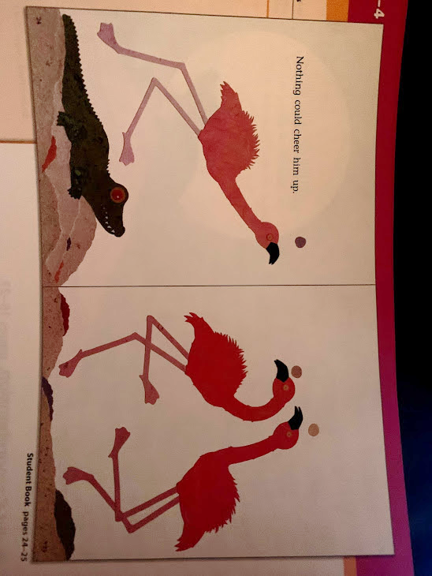

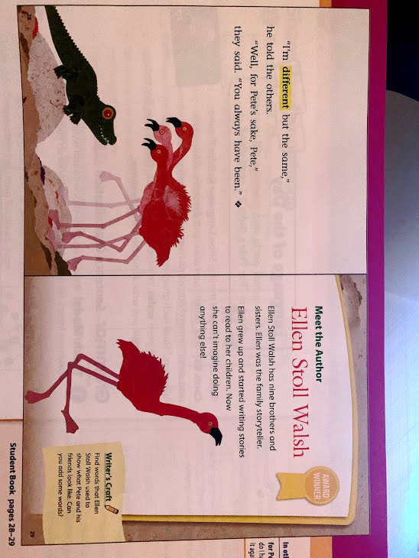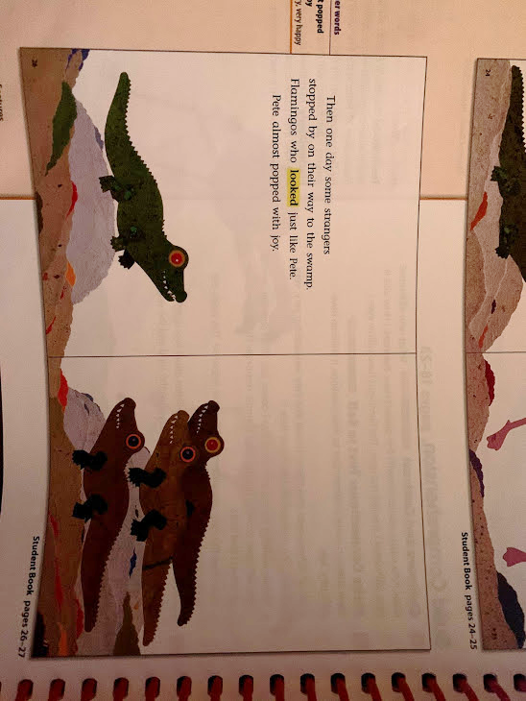

Activities! You are welcome to do all of these activities but please do at least three of them.

1. Have your child explain how the animals, from the story above, are alike and different.

2. Have your child choose an animal, from the story above, and have them write what parts and coverings the animal has. This might need a visual model, so write out what your child says and then have them copy it on a separate sheet of paper.

3. Have your child draw one, or all, of the animals from the story on a separate sheet of paper.

4. Have your child re-read the story out loud with the help from you or a sibling.

5. Have your child practice these simple sight words 5 times each (write, tell, is, what, saw). This means to say the word, have the child say the word, and write the word.